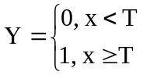

Y={0, x<=0; x/T, 0<x<T; 1, x>=T} 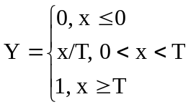

Y={-1, atan(x)<-1; atan(x), -1<=atan(x)<=1; 1, atan(x)>1} 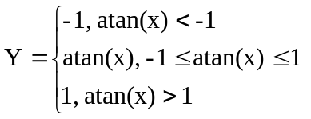

Y=1/(1+exp(-alpha*x)) 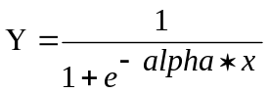

Y=sin(x) 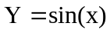

Y=exp(x) 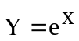

Y=x 